**Expert ID/Name: Nstructive**

**Date: 10-Nov-2020**

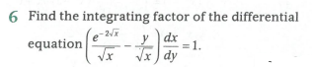

|  |
| --- |
| Answer for Short / Simple / Direct Question |

|  |
| --- |
| **Tips:**  1 .Integrating factor of  is .  2. |

**Answer:**

|  |  |  |  |  |  |  |  |  |
| --- | --- | --- | --- | --- | --- | --- | --- | --- |
| Given :  To find: Integrating factor of  Explanation: -  Step1:   |  |  | | --- | --- | | Instruction: | Convert the given differential equation into the form of | | Calculation: | Given differential equation is    Compare with |   Step 2:   |  |  | | --- | --- | | Instruction: | 1. Integrating factor of  is .  2. | | Calculation: | Hence, IF of is . | |
| Verified Answer: -Hence verified. |